Lesson 4 Introduction to R (Applied)

R Markdown

#################################
#####Basic commands#############
################################
x <- c(1,3,5,7) #create a vector of number, "c" is for "concatenate"
#x it gives us back the vector
#not only "<-" but also "="
y = c(1,2,3,4)
y
## [1] 1 2 3 4
z <- c(12, 34, 56); z
## [1] 12 34 56
#if we write in the console, we can type the up arrow to display the previous commands!
y[2] #second element in y
## [1] 2
y
## [1] 1 2 3 4
third_element_z <- z[3]
#we can add two sets of numbers together
length(x) #check the length
## [1] 4
length(y)
## [1] 4
x+y
## [1] 2 5 8 11
#we can give a name
sum <- x+y; sum
## [1] 2 5 8 11
###############################
########ls() and rm()##########
###############################
ls() #list...what we have done
## [1] "sum" "third_element_z" "x" "y"
## [5] "z"
rm(x) #rm means remove
#x #not found
ls()
## [1] "sum" "third_element_z" "y" "z"
#we can remove all objects at once
rm(list=ls())
ls() #character(0) means that the global environment is empty.
## character(0)
#how can we create a matrix?
# with the matrix function!
X = matrix(data= c(1,2,3,4), nrow=2, ncol=2)
X
## [,1] [,2]
## [1,] 1 3
## [2,] 2 4
#or without "data=" and "nrow=" and "ncol="
X = matrix (c(1,2,3,4), 2, 2); X
## [,1] [,2]
## [1,] 1 3
## [2,] 2 4
#if we want to populate the matrix in order of the rows
Y = matrix(c(1,2,3,4), 2, 2, byrow= TRUE); Y
## [,1] [,2]
## [1,] 1 2
## [2,] 3 4
dim(Y) #it is useful to have a look about the conformability
## [1] 2 2
A <- matrix(c(1, 2, -4, 18, 23, 15, 5, 12, 67, 32, 11, 34), 4, 3);A
## [,1] [,2] [,3]
## [1,] 1 23 67
## [2,] 2 15 32
## [3,] -4 5 11
## [4,] 18 12 34
dim(A)
## [1] 4 3
A[2,3] #element in second row and third column
## [1] 32
A[1,] #elements in first row
## [1] 1 23 67
A[,2] #elements in second column
## [1] 23 15 5 12
A
## [,1] [,2] [,3]
## [1,] 1 23 67
## [2,] 2 15 32
## [3,] -4 5 11
## [4,] 18 12 34
A[,c(1,3)] #elements in first and third col
## [,1] [,2]
## [1,] 1 67
## [2,] 2 32
## [3,] -4 11
## [4,] 18 34
A
## [,1] [,2] [,3]
## [1,] 1 23 67
## [2,] 2 15 32
## [3,] -4 5 11
## [4,] 18 12 34
#operations
sqrt(A)
## [,1] [,2] [,3]
## [1,] 1.000000 4.795832 8.185353
## [2,] 1.414214 3.872983 5.656854
## [3,] NaN 2.236068 3.316625
## [4,] 4.242641 3.464102 5.830952
A^2
## [,1] [,2] [,3]
## [1,] 1 529 4489
## [2,] 4 225 1024
## [3,] 16 25 121
## [4,] 324 144 1156
######INDEXING DATA##############
A <- matrix(1:16, 4, 4); A
## [,1] [,2] [,3] [,4]
## [1,] 1 5 9 13
## [2,] 2 6 10 14
## [3,] 3 7 11 15
## [4,] 4 8 12 16
A[3,2]
## [1] 7
A[2,3] #it's not the same thing
## [1] 10
#diagonal matrix
B<-diag(c(1,5,-2,-8)); B
## [,1] [,2] [,3] [,4]
## [1,] 1 0 0 0
## [2,] 0 5 0 0
## [3,] 0 0 -2 0
## [4,] 0 0 0 -8
diagonale <- diag(B); diagonale
## [1] 1 5 -2 -8
I2 <- diag(c(1,1)); I2
## [,1] [,2]
## [1,] 1 0
## [2,] 0 1
I4 <- diag(1, 4, 4);I4
## [,1] [,2] [,3] [,4]
## [1,] 1 0 0 0
## [2,] 0 1 0 0
## [3,] 0 0 1 0
## [4,] 0 0 0 1
##############################
###### cbind and rbind #######
##############################
B <- c(7, 5, 3, 1)
C <- c(6, 8, 9, 9)
D <- cbind(B, C); D
## B C
## [1,] 7 6
## [2,] 5 8
## [3,] 3 9
## [4,] 1 9
E <- rbind(B, C); E
## [,1] [,2] [,3] [,4]
## B 7 5 3 1
## C 6 8 9 9
###################################################
###################################################
###################################################
A <- matrix(c(1, 2, 3, 4, 5, 6), 3, 2); A
## [,1] [,2]
## [1,] 1 4
## [2,] 2 5
## [3,] 3 6
B <- matrix(c(9, 5, 7, 8, 10, 11), 3, 2); B
## [,1] [,2]
## [1,] 9 8
## [2,] 5 10
## [3,] 7 11
C <- A+B; C
## [,1] [,2]
## [1,] 10 12
## [2,] 7 15
## [3,] 10 17
D <- A-B; D
## [,1] [,2]
## [1,] -8 -4
## [2,] -3 -5
## [3,] -4 -5
D <- matrix(c(7, 8, 9, 10, 11, 12), 2, 3)
A%*%D
## [,1] [,2] [,3]
## [1,] 39 49 59
## [2,] 54 68 82
## [3,] 69 87 105
#########################################
college <- read.csv("https://uclspp.github.io/datasets/data/College.csv")
rownames ( college )= college [,1]
fix ( college )
college = college [,-1]
fix ( college )
summary(college)
## Private Apps Accept Enroll
## Length:777 Min. : 81 Min. : 72 Min. : 35
## Class :character 1st Qu.: 776 1st Qu.: 604 1st Qu.: 242
## Mode :character Median : 1558 Median : 1110 Median : 434
## Mean : 3002 Mean : 2019 Mean : 780
## 3rd Qu.: 3624 3rd Qu.: 2424 3rd Qu.: 902
## Max. :48094 Max. :26330 Max. :6392
## Top10perc Top25perc F.Undergrad P.Undergrad
## Min. : 1.00 Min. : 9.0 Min. : 139 Min. : 1.0
## 1st Qu.:15.00 1st Qu.: 41.0 1st Qu.: 992 1st Qu.: 95.0
## Median :23.00 Median : 54.0 Median : 1707 Median : 353.0
## Mean :27.56 Mean : 55.8 Mean : 3700 Mean : 855.3
## 3rd Qu.:35.00 3rd Qu.: 69.0 3rd Qu.: 4005 3rd Qu.: 967.0
## Max. :96.00 Max. :100.0 Max. :31643 Max. :21836.0
## Outstate Room.Board Books Personal
## Min. : 2340 Min. :1780 Min. : 96.0 Min. : 250
## 1st Qu.: 7320 1st Qu.:3597 1st Qu.: 470.0 1st Qu.: 850
## Median : 9990 Median :4200 Median : 500.0 Median :1200
## Mean :10441 Mean :4358 Mean : 549.4 Mean :1341
## 3rd Qu.:12925 3rd Qu.:5050 3rd Qu.: 600.0 3rd Qu.:1700
## Max. :21700 Max. :8124 Max. :2340.0 Max. :6800
## PhD Terminal S.F.Ratio perc.alumni
## Min. : 8.00 Min. : 24.0 Min. : 2.50 Min. : 0.00
## 1st Qu.: 62.00 1st Qu.: 71.0 1st Qu.:11.50 1st Qu.:13.00
## Median : 75.00 Median : 82.0 Median :13.60 Median :21.00
## Mean : 72.66 Mean : 79.7 Mean :14.09 Mean :22.74
## 3rd Qu.: 85.00 3rd Qu.: 92.0 3rd Qu.:16.50 3rd Qu.:31.00
## Max. :103.00 Max. :100.0 Max. :39.80 Max. :64.00
## Expend Grad.Rate
## Min. : 3186 Min. : 10.00
## 1st Qu.: 6751 1st Qu.: 53.00
## Median : 8377 Median : 65.00
## Mean : 9660 Mean : 65.46
## 3rd Qu.:10830 3rd Qu.: 78.00
## Max. :56233 Max. :118.00
###
str(college)
## 'data.frame': 777 obs. of 18 variables:
## $ Private : chr "Yes" "Yes" "Yes" "Yes" ...
## $ Apps : num 1660 2186 1428 417 193 ...
## $ Accept : num 1232 1924 1097 349 146 ...
## $ Enroll : num 721 512 336 137 55 158 103 489 227 172 ...
## $ Top10perc : num 23 16 22 60 16 38 17 37 30 21 ...
## $ Top25perc : num 52 29 50 89 44 62 45 68 63 44 ...
## $ F.Undergrad: num 2885 2683 1036 510 249 ...
## $ P.Undergrad: num 537 1227 99 63 869 ...
## $ Outstate : num 7440 12280 11250 12960 7560 ...
## $ Room.Board : num 3300 6450 3750 5450 4120 ...
## $ Books : num 450 750 400 450 800 500 500 450 300 660 ...
## $ Personal : num 2200 1500 1165 875 1500 ...
## $ PhD : num 70 29 53 92 76 67 90 89 79 40 ...
## $ Terminal : num 78 30 66 97 72 73 93 100 84 41 ...
## $ S.F.Ratio : num 18.1 12.2 12.9 7.7 11.9 9.4 11.5 13.7 11.3 11.5 ...
## $ perc.alumni: num 12 16 30 37 2 11 26 37 23 15 ...
## $ Expend : num 7041 10527 8735 19016 10922 ...
## $ Grad.Rate : num 60 56 54 59 15 55 63 73 80 52 ...
college[,1] = as.numeric(factor(college[,1]))
pairs(college[, 1:10])
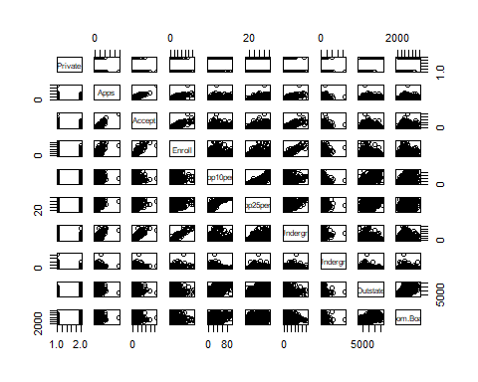
plot(Outstate ~ as.factor(Private), data = college,
xlab = "Private University",
ylab = "Tuition in $")
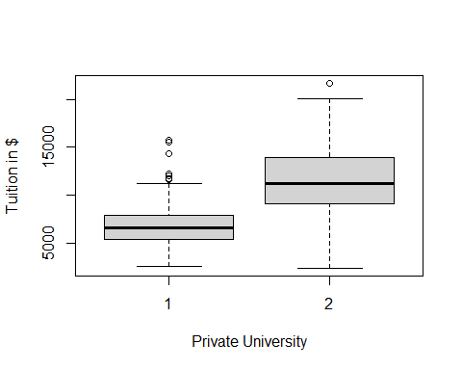
Elite =rep ("No", nrow( college ))
Elite [ college$Top10perc >50]=" Yes "
Elite =as.factor (Elite )
college =data.frame (college, Elite )
#You can do the same all in one line using the `ifelse` function.
college$Elite <- as.factor(ifelse(college$Top10perc > 50, "Yes", "No"))
summary(Elite)
## Yes No
## 78 699
plot(Outstate ~ Elite, data = college,
xlab = "Elite University",
ylab = "Tuition in $")
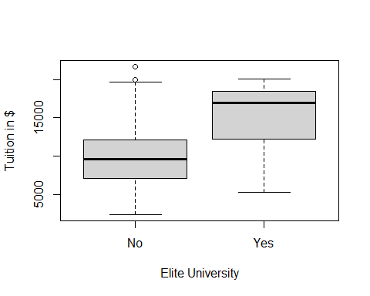
par(mfrow=c(2,2))
hist(college$Apps, xlab = "Applications Received", main = "")
hist(college$perc.alumni, col=2, xlab = "% of alumni who donate", main = "")
hist(college$S.F.Ratio, col=3, breaks=10, xlab = "Student/faculty ratio", main = "")
hist(college$Expend, breaks=100, xlab = "Instructional expenditure per student", main = "")
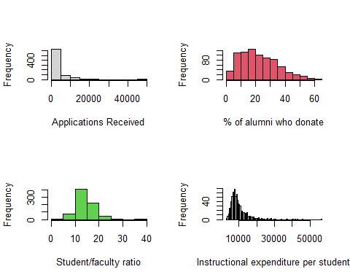
# University with the most students in the top 10% of class
row.names(college)[which.max(college$Top10perc)]
## [1] "Massachusetts Institute of Technology"
acceptance_rate <- college$Accept / college$Apps
acceptance_rate
## [1] 0.7421687 0.8801464 0.7682073 0.8369305 0.7564767 0.8160136 0.9631728
## [8] 0.9057399 0.8082852 0.8556701 0.8227483 0.7164404 0.6615776 0.8524073
## [15] 0.6336032 0.7697183 0.2305904 0.7467105 0.6230088 0.5652542 0.9270687
## [22] 0.6377684 0.8336026 0.8047467 0.4717514 0.9971165 0.7962529 0.8997085
## [29] 0.7749245 0.8823842 0.9526938 0.8417722 0.8867624 0.8023256 0.8082840
## [36] 0.7356322 0.4387435 0.5616987 0.7919192 0.8804938 0.7308684 0.8760843
## [43] 0.7816456 0.7983607 0.6992424 0.7259934 0.9810127 0.6300578 0.6722447
## [50] 0.6571582 0.9293850 0.9108911 0.7649402 0.6986634 0.7304348 0.6720000
## [57] 0.4470692 0.9496021 0.7427746 0.6441660 0.3036353 0.7926711 0.7449210
## [64] 0.9062915 0.6552795 0.7465940 0.8551532 0.8954082 0.8031026 0.7334691
## [71] 0.2573494 0.5529010 0.5823152 0.8000000 0.8624047 0.8247078 0.5974283
## [78] 0.4387211 0.4886698 0.7255507 0.8475336 0.6415908 0.6922170 0.7686646
## [85] 0.7910704 0.9000000 0.5861173 0.5958983 0.8543103 0.8677007 0.8830446
## [92] 0.8140315 0.7478123 0.8125577 0.8352338 0.8923837 0.7822165 0.8339709
## [99] 0.8455285 0.8767677 0.6589018 0.8674981 0.6089466 0.8760949 0.7220826
## [106] 0.8390805 0.8766041 0.8039625 0.9292453 0.7426901 0.8888889 0.5909091
## [113] 0.8674972 0.5827759 0.4123656 0.7131971 0.7391304 0.8983441 0.6518289
## [120] 0.8142235 0.7375746 0.7483444 0.4631320 0.5131796 0.6201117 0.6580050
## [127] 0.7769424 0.6849894 0.7674419 0.7789934 0.9211087 0.8043053 0.8085586
## [134] 0.6754832 0.8186813 0.8368794 0.8869048 0.5647963 0.4364198 0.8966667
## [141] 0.4917368 0.6659633 0.5031847 0.8331072 0.2856720 0.9466192 0.9310345
## [148] 0.7223837 0.7632576 0.5093904 0.9250000 0.8641092 0.9558477 0.7043147
## [155] 0.7929648 0.7147806 0.9563492 0.8683761 0.2647025 0.4028656 0.8073555
## [162] 0.9772492 0.8251267 0.8304915 0.8424021 0.9493088 0.6886887 0.8940731
## [169] 0.9138889 0.9304636 0.8199802 0.9192569 0.7338597 0.9285714 0.2823265
## [176] 0.7407953 0.6860039 0.8198198 0.8997361 0.8056769 0.6873849 0.7598714
## [183] 0.9053498 0.7926357 0.7798875 0.7625155 0.7172272 0.8489796 0.7687638
## [190] 0.8200571 0.8444444 0.4900071 1.0000000 0.8452200 0.8107143 0.6113270
## [197] 0.6994147 0.7312715 0.8267364 0.5045936 0.8115049 0.6288566 0.7530775
## [204] 0.7452579 0.8419244 0.6842857 0.8206395 0.9189339 0.8173599 0.7860697
## [211] 0.8619626 0.6122905 0.7919075 0.9028228 0.7743506 0.8378378 0.7994012
## [218] 0.8974042 0.7652574 0.6427937 0.9532325 0.2591993 0.5776445 0.6171896
## [225] 0.8074713 0.6857620 0.7393365 0.8080594 0.8382789 0.9000000 0.7063423
## [232] 0.7810219 0.7459459 0.7525653 0.8051282 0.8125000 0.7588235 0.6812163
## [239] 0.4456042 0.8768719 0.8104154 0.6236842 0.5678344 0.8200795 0.7882497
## [246] 0.5231262 0.8320080 0.9079229 0.6205694 0.8281325 0.1561486 0.4153958
## [253] 0.8665851 0.8760632 0.8097826 0.7906725 0.7741815 0.7889068 0.8272425
## [260] 0.8082976 0.8662383 0.8282403 0.8552632 0.9555556 0.3283333 0.9017981
## [267] 0.9192751 0.8803132 0.7744875 0.7712245 0.4400000 0.9440299 0.7970765
## [274] 0.8413147 0.7983963 0.5755102 0.7215863 0.8809778 0.7612619 0.4709080
## [281] 0.8686441 0.4812310 0.6694215 0.8711276 0.4066557 0.8031212 0.7284345
## [288] 0.8547264 0.6930272 0.9762309 0.7837232 0.8510274 0.6952984 0.8264642
## [295] 0.7232143 0.8450704 0.8125000 0.8891967 0.6261523 0.5990025 0.7334559
## [302] 0.6516854 0.9094567 0.7384418 0.6474128 0.8653516 0.7618665 0.8156463
## [309] 0.7647908 0.6728154 0.7589377 0.8114754 0.8742138 0.7541456 0.9098787
## [316] 0.7141042 0.6572289 0.5975309 0.7610506 0.5255556 0.6204482 0.6807426
## [323] 0.7818403 0.5230999 0.8327218 0.8944514 0.7696271 0.7064756 0.8979376
## [330] 0.8267673 0.8986443 0.7814930 0.8542141 0.9383178 0.5090167 0.7540541
## [337] 0.8672769 0.7988048 0.7113487 0.7796258 0.8695086 0.8131068 0.5959032
## [344] 0.6702600 0.8928571 0.8674870 0.8837675 0.5006897 0.6841004 0.7697842
## [351] 0.8204038 0.6065574 0.7231330 0.7759711 0.3338013 1.0000000 0.5538922
## [358] 0.7110727 0.6976190 0.7296588 0.6897881 0.9008168 0.7778900 0.9191919
## [365] 0.7933410 0.8429484 0.8333885 0.8739496 1.0000000 0.5115621 0.7557377
## [372] 0.8732687 0.9215470 0.8940016 0.6481481 0.7701528 0.8437500 0.8413706
## [379] 0.7503817 0.8369384 0.6948652 0.9510490 0.8102857 0.4076628 0.8479087
## [386] 0.8861589 0.7751623 0.4525351 0.9095563 0.8276644 0.7300000 0.9892473
## [393] 0.9234043 0.8614130 0.8738462 0.8773656 0.5940171 0.8173516 0.8290076
## [400] 0.9509804 0.7288607 0.8584270 0.8313796 0.6764133 0.8426610 0.6471527
## [407] 0.7636595 0.5328822 0.8279817 0.8090090 0.6429942 0.6423373 0.6642844
## [414] 0.8485222 0.7843833 0.7739218 0.7763441 0.7577815 0.7135535 0.8370396
## [421] 0.6742948 0.9289117 0.8344156 0.9430233 0.4231426 0.9323006 0.8548813
## [428] 0.8487340 0.5791126 0.5675559 0.8194444 0.7976839 0.7527896 0.7762557
## [435] 0.8984169 0.9858247 0.8653251 0.8054813 0.8494505 0.5788562 0.4542151
## [442] 0.8683718 0.7106383 0.9003181 0.8199153 0.5355423 0.5331065 0.7146933
## [449] 0.7768496 0.8185956 0.8323699 0.8476621 0.9900990 0.5560459 0.8491965
## [456] 0.8502857 0.7482332 0.9288981 0.7689464 0.1544863 0.6510994 0.8596588
## [463] 0.7596899 0.6897561 0.5800108 0.8582953 0.4583333 0.7481649 0.8850575
## [470] 0.7304171 0.9016393 0.8336669 0.7953953 0.6759621 0.8534923 0.7975207
## [477] 0.8037719 0.9176471 0.7000000 0.8486683 0.6477209 0.7396313 0.3746073
## [484] 0.5474695 0.5204991 0.4649957 0.8218466 0.8004459 0.7412888 0.8325359
## [491] 0.7793427 0.7877629 0.8574491 0.7434783 0.8187275 0.7951568 0.8253425
## [498] 0.8667274 0.8265766 0.9155251 0.8666667 0.7225131 0.7442171 0.8798257
## [505] 0.8500000 0.8242038 0.7852761 0.8477612 0.5431689 0.8303571 0.7466496
## [512] 0.6914655 0.5565217 0.6203787 0.7071918 0.7391813 0.8588335 0.7281324
## [519] 0.7790647 0.8482906 0.5639395 0.8240741 0.6524823 0.9030172 0.7796610
## [526] 0.8582677 0.9153318 0.6354531 0.5463248 0.9223370 0.8198159 0.8557457
## [533] 0.8831169 0.8641732 0.8033016 1.0000000 0.8587774 0.8958930 0.9906542
## [540] 0.7276995 0.7331190 0.7102473 0.3331538 0.9731183 0.8817999 0.8606811
## [547] 0.7777778 0.6610970 0.8638743 0.6095346 0.5186567 0.8205953 0.9317841
## [554] 0.8924731 0.7073171 0.9000000 0.7880539 0.7064480 0.3928838 0.6308283
## [561] 0.6799231 0.4263293 0.6415985 0.5569853 0.4886208 0.5695000 0.6609628
## [568] 0.4461207 0.5737133 0.5305885 0.4296940 0.6457019 0.7266667 0.5965078
## [575] 0.7213740 0.8701299 0.6929465 0.7120623 0.3398278 0.6172979 0.7844828
## [582] 0.7267514 0.9092628 0.7518926 0.8511066 0.7468354 0.8462838 0.8280000
## [589] 0.8240901 0.8686391 0.9604743 0.4585482 0.8732171 0.5879660 0.7651822
## [596] 0.8333333 0.7496907 0.7287075 0.5942492 0.8059109 0.7933884 0.4898426
## [603] 0.6041667 0.7011686 0.9607419 0.4152368 0.6863932 0.4235614 0.7844575
## [610] 0.4724323 0.8100656 0.7382640 0.8634361 0.8321019 0.7279524 0.6728312
## [617] 0.7885653 0.9687500 0.7757634 0.7100040 0.7015152 0.7951191 0.7270950
## [624] 0.7799719 0.6830868 0.8581036 0.6482107 0.6067627 0.6399414 0.6647351
## [631] 0.8367347 0.8264642 0.6076364 0.7217324 0.8598144 0.7759187 0.7562482
## [638] 0.6756475 0.7457061 0.5994513 0.5787045 0.8800728 0.7053544 0.9728290
## [645] 0.7051916 0.7323009 0.6602517 0.9563486 0.6203474 0.7835897 0.5571998
## [652] 0.4100438 0.7652938 0.7963783 0.6351507 0.8098668 0.6961111 0.6195111
## [659] 0.7245931 0.8153958 0.4805195 0.8370230 0.7799791 0.4221397 0.7434195
## [666] 0.8447099 0.6988131 0.8037955 0.4613035 0.6271960 0.6952211 0.7463140
## [673] 0.9824561 0.6580183 0.6603774 0.7558820 0.6161550 0.6949056 0.8843683
## [680] 0.8965952 0.7171930 0.8784638 0.7486631 0.7188545 0.7799451 0.6488612
## [687] 0.7351198 0.7227926 0.8121187 0.6685121 0.9094626 0.8814524 0.7840271
## [694] 0.3397060 0.5510236 0.8048780 0.7581951 1.0000000 0.8452273 0.8048983
## [701] 0.7336420 0.7212052 0.7471661 0.6817496 0.7333810 0.8000000 0.9347826
## [708] 0.8322892 0.6019766 0.5287324 0.7201959 0.7046141 0.8144192 0.7458630
## [715] 0.8716838 0.6122449 0.8006182 0.6866894 0.7787500 0.7168079 0.4225402
## [722] 0.8150183 0.7068182 0.8724614 0.8429119 0.3306184 0.7791563 0.8928135
## [729] 0.6870917 1.0000000 0.8218487 0.5107143 0.6947368 0.4314335 0.7547170
## [736] 0.8493243 0.8234694 0.4134535 0.5442941 0.9123711 0.8939974 0.7813275
## [743] 0.8165975 0.7844442 0.8915152 0.6006662 0.6422134 0.6935484 0.8353474
## [750] 0.8694779 0.7851690 0.7505263 0.6424581 0.7899885 0.8361019 0.5362708
## [757] 0.6359310 0.8260482 0.6975222 0.8773758 0.8003619 0.8250377 0.9275053
## [764] 0.2974200 0.7784431 0.8208232 0.6156391 0.7780172 0.8421053 0.8787266
## [771] 0.6229181 0.8359827 0.6895767 0.9213885 0.9132093 0.2291453 0.6206089
# lowest acceptance rate
row.names(college)[which.min(acceptance_rate)]
## [1] "Princeton University"
# highest acceptance rate
row.names(college)[which.max(acceptance_rate)]
## [1] "Emporia State University"
# High tuition correlates to high graduation rate
plot(Grad.Rate ~ Outstate, data = college)
#Which university receives a very larger number of applications than others, approximately 50 thousands.
summary(college$Apps)
## Min. 1st Qu. Median Mean 3rd Qu. Max.
## 81 776 1558 3002 3624 48094
row.names(college[college$Apps>25000, ])
## [1] "Rutgers at New Brunswick"
############################
library (MASS)
head(Boston)
## crim zn indus chas nox rm age dis rad tax ptratio black lstat
## 1 0.00632 18 2.31 0 0.538 6.575 65.2 4.0900 1 296 15.3 396.90 4.98
## 2 0.02731 0 7.07 0 0.469 6.421 78.9 4.9671 2 242 17.8 396.90 9.14
## 3 0.02729 0 7.07 0 0.469 7.185 61.1 4.9671 2 242 17.8 392.83 4.03
## 4 0.03237 0 2.18 0 0.458 6.998 45.8 6.0622 3 222 18.7 394.63 2.94
## 5 0.06905 0 2.18 0 0.458 7.147 54.2 6.0622 3 222 18.7 396.90 5.33
## 6 0.02985 0 2.18 0 0.458 6.430 58.7 6.0622 3 222 18.7 394.12 5.21
## medv
## 1 24.0
## 2 21.6
## 3 34.7
## 4 33.4
## 5 36.2
## 6 28.7
#Part a
dim(Boston)
## [1] 506 14
#The Boston housing dataset is 506 rows and 14 columns.
#Each row represents a Boston suburb.
#The columns represent:
#crim - Per capita crime rate by town
#zn - Proportion of residential land zoned for lots over 25,000 sq.ft.
#indus - Proportion of non-retail business acres per town
#chas - Charles River variable (= 1 if tract bounds river; 0 otherwise)
#nox - Nitrogen oxides concentration (parts per 10 million)
#rm - Average number of rooms per dwelling
#age - Proportion of owner-occupied units built prior to 1940
#dis - Weighted mean of distances to five Boston employment centres
#rad - Index of accessibility to radial highways
#tax - Full-value property-tax rate per $10,000
#ptratio - Pupil-teacher ratio by town
#black - 1000(Bk - 0.63)^2 where Bk is the proportion of blacks by town
#lstat - Lower status of the population (percent)
#medv - Median value of owner-occupied homes in $1000s
#Part b
str(Boston)
## 'data.frame': 506 obs. of 14 variables:
## $ crim : num 0.00632 0.02731 0.02729 0.03237 0.06905 ...
## $ zn : num 18 0 0 0 0 0 12.5 12.5 12.5 12.5 ...
## $ indus : num 2.31 7.07 7.07 2.18 2.18 2.18 7.87 7.87 7.87 7.87 ...
## $ chas : int 0 0 0 0 0 0 0 0 0 0 ...
## $ nox : num 0.538 0.469 0.469 0.458 0.458 0.458 0.524 0.524 0.524 0.524 ...
## $ rm : num 6.58 6.42 7.18 7 7.15 ...
## $ age : num 65.2 78.9 61.1 45.8 54.2 58.7 66.6 96.1 100 85.9 ...
## $ dis : num 4.09 4.97 4.97 6.06 6.06 ...
## $ rad : int 1 2 2 3 3 3 5 5 5 5 ...
## $ tax : num 296 242 242 222 222 222 311 311 311 311 ...
## $ ptratio: num 15.3 17.8 17.8 18.7 18.7 18.7 15.2 15.2 15.2 15.2 ...
## $ black : num 397 397 393 395 397 ...
## $ lstat : num 4.98 9.14 4.03 2.94 5.33 ...
## $ medv : num 24 21.6 34.7 33.4 36.2 28.7 22.9 27.1 16.5 18.9 ...
Boston$chas <- as.numeric(Boston$chas)
Boston$rad <- as.numeric(Boston$rad)
pairs(Boston)
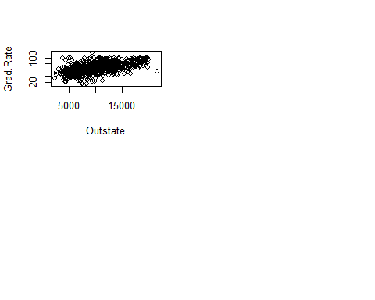
#some variables appear to be correlated.
#Part c
cor(Boston)
## crim zn indus chas nox
## crim 1.00000000 -0.20046922 0.40658341 -0.055891582 0.42097171
## zn -0.20046922 1.00000000 -0.53382819 -0.042696719 -0.51660371
## indus 0.40658341 -0.53382819 1.00000000 0.062938027 0.76365145
## chas -0.05589158 -0.04269672 0.06293803 1.000000000 0.09120281
## nox 0.42097171 -0.51660371 0.76365145 0.091202807 1.00000000
## rm -0.21924670 0.31199059 -0.39167585 0.091251225 -0.30218819
## age 0.35273425 -0.56953734 0.64477851 0.086517774 0.73147010
## dis -0.37967009 0.66440822 -0.70802699 -0.099175780 -0.76923011
## rad 0.62550515 -0.31194783 0.59512927 -0.007368241 0.61144056
## tax 0.58276431 -0.31456332 0.72076018 -0.035586518 0.66802320
## ptratio 0.28994558 -0.39167855 0.38324756 -0.121515174 0.18893268
## black -0.38506394 0.17552032 -0.35697654 0.048788485 -0.38005064
## lstat 0.45562148 -0.41299457 0.60379972 -0.053929298 0.59087892
## medv -0.38830461 0.36044534 -0.48372516 0.175260177 -0.42732077
## rm age dis rad tax ptratio
## crim -0.21924670 0.35273425 -0.37967009 0.625505145 0.58276431 0.2899456
## zn 0.31199059 -0.56953734 0.66440822 -0.311947826 -0.31456332 -0.3916785
## indus -0.39167585 0.64477851 -0.70802699 0.595129275 0.72076018 0.3832476
## chas 0.09125123 0.08651777 -0.09917578 -0.007368241 -0.03558652 -0.1215152
## nox -0.30218819 0.73147010 -0.76923011 0.611440563 0.66802320 0.1889327
## rm 1.00000000 -0.24026493 0.20524621 -0.209846668 -0.29204783 -0.3555015
## age -0.24026493 1.00000000 -0.74788054 0.456022452 0.50645559 0.2615150
## dis 0.20524621 -0.74788054 1.00000000 -0.494587930 -0.53443158 -0.2324705
## rad -0.20984667 0.45602245 -0.49458793 1.000000000 0.91022819 0.4647412
## tax -0.29204783 0.50645559 -0.53443158 0.910228189 1.00000000 0.4608530
## ptratio -0.35550149 0.26151501 -0.23247054 0.464741179 0.46085304 1.0000000
## black 0.12806864 -0.27353398 0.29151167 -0.444412816 -0.44180801 -0.1773833
## lstat -0.61380827 0.60233853 -0.49699583 0.488676335 0.54399341 0.3740443
## medv 0.69535995 -0.37695457 0.24992873 -0.381626231 -0.46853593 -0.5077867
## black lstat medv
## crim -0.38506394 0.4556215 -0.3883046
## zn 0.17552032 -0.4129946 0.3604453
## indus -0.35697654 0.6037997 -0.4837252
## chas 0.04878848 -0.0539293 0.1752602
## nox -0.38005064 0.5908789 -0.4273208
## rm 0.12806864 -0.6138083 0.6953599
## age -0.27353398 0.6023385 -0.3769546
## dis 0.29151167 -0.4969958 0.2499287
## rad -0.44441282 0.4886763 -0.3816262
## tax -0.44180801 0.5439934 -0.4685359
## ptratio -0.17738330 0.3740443 -0.5077867
## black 1.00000000 -0.3660869 0.3334608
## lstat -0.36608690 1.0000000 -0.7376627
## medv 0.33346082 -0.7376627 1.0000000
#Based on the correlation coefficients, there is indeed an association between the per capita crime rate (crim) and the other predictors.
#Part d
summary(Boston$crim)
## Min. 1st Qu. Median Mean 3rd Qu. Max.
## 0.00632 0.08204 0.25651 3.61352 3.67708 88.97620
#Considering that the median and maximum crime rate values are respectively about 0.26% and 89%, there are indeed some neighborhoods where the crime rate is alarmingly high
library(ggplot2)
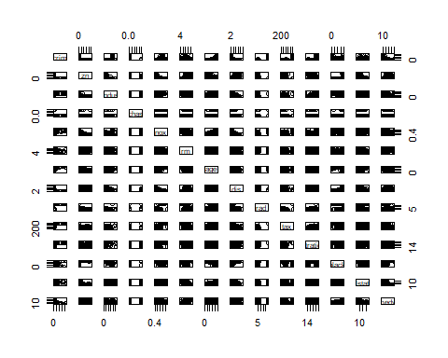
qplot(Boston$crim, binwidth=5 , xlab = "Crime rate", ylab="Number of Suburbs" )
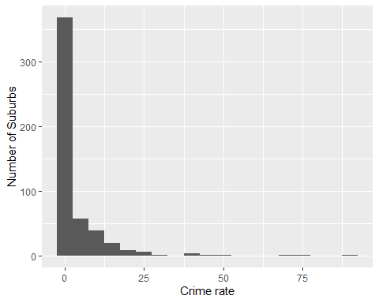
summary(Boston$tax)
## Min. 1st Qu. Median Mean 3rd Qu. Max.
## 187.0 279.0 330.0 408.2 666.0 711.0
qplot(Boston$tax, binwidth=50 , xlab = "Full-value property-tax rate per $10,000", ylab="Number of Suburbs")
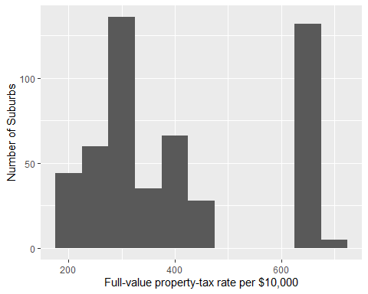
#Based on the histogram of the Tax rates, they are few neighborhoods where rates are relative higher.
#The median and average tax amount are $330 and $408.20 ( per Full-value property-tax rate per $10,000) respectively.
summary(Boston$ptratio)
## Min. 1st Qu. Median Mean 3rd Qu. Max.
## 12.60 17.40 19.05 18.46 20.20 22.00
qplot(Boston$ptratio, binwidth=5, xlab ="Pupil-teacher ratio by town", ylab="Number of Suburbs")
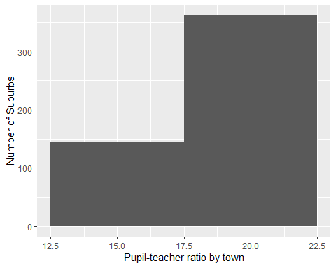
hist(Boston$crim[Boston$crim > 1], breaks=25)
# most cities have low crime rates, but there is a long tail: 18 suburbs appear to have a crime rate > 20
hist(Boston$tax, breaks=25)
# there is a large divide between suburbs with low tax rates and a peak at 660-680
hist(Boston$ptratio, breaks=25)
# a skew towards high ratios, but no particularly high ratios
#Part e
#How many of the suburbs in this data set bound the Charles river?
nrow(subset(Boston, chas ==1))
## [1] 35
#There are 35 such suburbs.
#Part f
#What is the median pupil-teacher ratio among the towns in this data set?
summary(Boston$ptratio)
## Min. 1st Qu. Median Mean 3rd Qu. Max.
## 12.60 17.40 19.05 18.46 20.20 22.00
#The median pupil-teacher ratio is 19 pupils for each teacher
#Part g
selection <- Boston[order(Boston$medv),]
selection[1,]
## crim zn indus chas nox rm age dis rad tax ptratio black lstat
## 399 38.3518 0 18.1 0 0.693 5.453 100 1.4896 24 666 20.2 396.9 30.59
## medv
## 399 5
selection[2,]
## crim zn indus chas nox rm age dis rad tax ptratio black lstat
## 406 67.9208 0 18.1 0 0.693 5.683 100 1.4254 24 666 20.2 384.97 22.98
## medv
## 406 5
#Suburb 399 and 406 have a median value of $5000.
summary(selection)
## crim zn indus chas
## Min. : 0.00632 Min. : 0.00 Min. : 0.46 Min. :0.00000
## 1st Qu.: 0.08205 1st Qu.: 0.00 1st Qu.: 5.19 1st Qu.:0.00000
## Median : 0.25651 Median : 0.00 Median : 9.69 Median :0.00000
## Mean : 3.61352 Mean : 11.36 Mean :11.14 Mean :0.06917
## 3rd Qu.: 3.67708 3rd Qu.: 12.50 3rd Qu.:18.10 3rd Qu.:0.00000
## Max. :88.97620 Max. :100.00 Max. :27.74 Max. :1.00000
## nox rm age dis
## Min. :0.3850 Min. :3.561 Min. : 2.90 Min. : 1.130
## 1st Qu.:0.4490 1st Qu.:5.886 1st Qu.: 45.02 1st Qu.: 2.100
## Median :0.5380 Median :6.208 Median : 77.50 Median : 3.207
## Mean :0.5547 Mean :6.285 Mean : 68.57 Mean : 3.795
## 3rd Qu.:0.6240 3rd Qu.:6.623 3rd Qu.: 94.08 3rd Qu.: 5.188
## Max. :0.8710 Max. :8.780 Max. :100.00 Max. :12.127
## rad tax ptratio black
## Min. : 1.000 Min. :187.0 Min. :12.60 Min. : 0.32
## 1st Qu.: 4.000 1st Qu.:279.0 1st Qu.:17.40 1st Qu.:375.38
## Median : 5.000 Median :330.0 Median :19.05 Median :391.44
## Mean : 9.549 Mean :408.2 Mean :18.46 Mean :356.67
## 3rd Qu.:24.000 3rd Qu.:666.0 3rd Qu.:20.20 3rd Qu.:396.23
## Max. :24.000 Max. :711.0 Max. :22.00 Max. :396.90
## lstat medv
## Min. : 1.73 Min. : 5.00
## 1st Qu.: 6.95 1st Qu.:17.02
## Median :11.36 Median :21.20
## Mean :12.65 Mean :22.53
## 3rd Qu.:16.95 3rd Qu.:25.00
## Max. :37.97 Max. :50.00
#Suburd #399: * Crime is very high compared to median and average rates of all Boston neighborhoods.
#* Highest proportion of owner proportion of owner-occupied units built prior to 1940.
#* One of the lowest weighted mean of distances to five Boston employment centres.
#* One of the highest full-value property-tax rate per $10,000.
#* One of the highest pupil-teacher ratio by town *
#Based on the previous results, suburb 399 can be classified as one of the least desirable places to live in Boston.
#Part h
rm_over_7 <- subset(Boston, rm>7)
nrow(rm_over_7)
## [1] 64
#There are 64 suburbs with more than 7 rooms per dwelling.
rm_over_8 <- subset(Boston, rm>8)
nrow(rm_over_8)
## [1] 13
#There are 13 suburbs with more than 7 rooms per dwelling.
summary(rm_over_8)
## crim zn indus chas
## Min. :0.02009 Min. : 0.00 Min. : 2.680 Min. :0.0000
## 1st Qu.:0.33147 1st Qu.: 0.00 1st Qu.: 3.970 1st Qu.:0.0000
## Median :0.52014 Median : 0.00 Median : 6.200 Median :0.0000
## Mean :0.71879 Mean :13.62 Mean : 7.078 Mean :0.1538
## 3rd Qu.:0.57834 3rd Qu.:20.00 3rd Qu.: 6.200 3rd Qu.:0.0000
## Max. :3.47428 Max. :95.00 Max. :19.580 Max. :1.0000
## nox rm age dis
## Min. :0.4161 Min. :8.034 Min. : 8.40 Min. :1.801
## 1st Qu.:0.5040 1st Qu.:8.247 1st Qu.:70.40 1st Qu.:2.288
## Median :0.5070 Median :8.297 Median :78.30 Median :2.894
## Mean :0.5392 Mean :8.349 Mean :71.54 Mean :3.430
## 3rd Qu.:0.6050 3rd Qu.:8.398 3rd Qu.:86.50 3rd Qu.:3.652
## Max. :0.7180 Max. :8.780 Max. :93.90 Max. :8.907
## rad tax ptratio black
## Min. : 2.000 Min. :224.0 Min. :13.00 Min. :354.6
## 1st Qu.: 5.000 1st Qu.:264.0 1st Qu.:14.70 1st Qu.:384.5
## Median : 7.000 Median :307.0 Median :17.40 Median :386.9
## Mean : 7.462 Mean :325.1 Mean :16.36 Mean :385.2
## 3rd Qu.: 8.000 3rd Qu.:307.0 3rd Qu.:17.40 3rd Qu.:389.7
## Max. :24.000 Max. :666.0 Max. :20.20 Max. :396.9
## lstat medv
## Min. :2.47 Min. :21.9
## 1st Qu.:3.32 1st Qu.:41.7
## Median :4.14 Median :48.3
## Mean :4.31 Mean :44.2
## 3rd Qu.:5.12 3rd Qu.:50.0
## Max. :7.44 Max. :50.0
summary(Boston)
## crim zn indus chas
## Min. : 0.00632 Min. : 0.00 Min. : 0.46 Min. :0.00000
## 1st Qu.: 0.08205 1st Qu.: 0.00 1st Qu.: 5.19 1st Qu.:0.00000
## Median : 0.25651 Median : 0.00 Median : 9.69 Median :0.00000
## Mean : 3.61352 Mean : 11.36 Mean :11.14 Mean :0.06917
## 3rd Qu.: 3.67708 3rd Qu.: 12.50 3rd Qu.:18.10 3rd Qu.:0.00000
## Max. :88.97620 Max. :100.00 Max. :27.74 Max. :1.00000
## nox rm age dis
## Min. :0.3850 Min. :3.561 Min. : 2.90 Min. : 1.130
## 1st Qu.:0.4490 1st Qu.:5.886 1st Qu.: 45.02 1st Qu.: 2.100
## Median :0.5380 Median :6.208 Median : 77.50 Median : 3.207
## Mean :0.5547 Mean :6.285 Mean : 68.57 Mean : 3.795
## 3rd Qu.:0.6240 3rd Qu.:6.623 3rd Qu.: 94.08 3rd Qu.: 5.188
## Max. :0.8710 Max. :8.780 Max. :100.00 Max. :12.127
## rad tax ptratio black
## Min. : 1.000 Min. :187.0 Min. :12.60 Min. : 0.32
## 1st Qu.: 4.000 1st Qu.:279.0 1st Qu.:17.40 1st Qu.:375.38
## Median : 5.000 Median :330.0 Median :19.05 Median :391.44
## Mean : 9.549 Mean :408.2 Mean :18.46 Mean :356.67
## 3rd Qu.:24.000 3rd Qu.:666.0 3rd Qu.:20.20 3rd Qu.:396.23
## Max. :24.000 Max. :711.0 Max. :22.00 Max. :396.90
## lstat medv
## Min. : 1.73 Min. : 5.00
## 1st Qu.: 6.95 1st Qu.:17.02
## Median :11.36 Median :21.20
## Mean :12.65 Mean :22.53
## 3rd Qu.:16.95 3rd Qu.:25.00
## Max. :37.97 Max. :50.00
# Relatively lower crime (comparing range), lower lstat (comparing range)
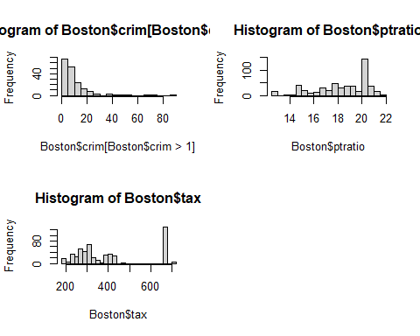
Note that the echo = FALSE parameter was added to the code chunk to prevent printing of the R code that generated the plot.

